class.



|  |
| --- |
| **D** |

|  |
| --- |
| **dance** |

Are you going to the dance this weekend?  
He was too shy to ask her to dance with him.  
The lights and loud music in the club made her want to dance.

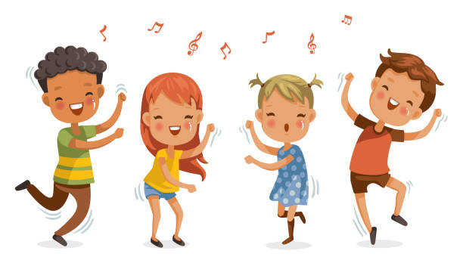

|  |
| --- |
| **dare** |

No one dares (dares to) speak freely about the political situation.  
Everyone in the office complains that he smells awful, but nobody dares (to) mention it to him.  
Do you dare (to) tell him the news?



|  |
| --- |
| **dark** |

The church was dark and quiet.  
Suddenly, the room went dark (=became dark).  
There were dark clouds in the sky.  
No, you can’t play outside, it’s too dark.

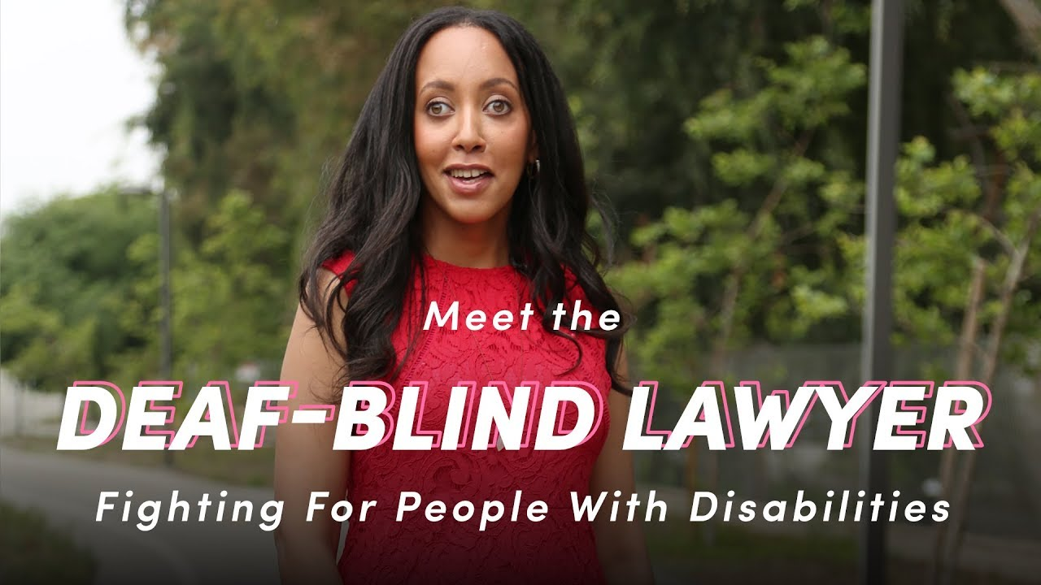

|  |
| --- |
| **deaf** |

Her father's going deaf.  
She's deaf in her left ear.  
She is deaf, but refuses to let her disability prevent her from doing what she wants to do.  
"Didn't you realize she was deaf?" "Of course I did."  
He's been deaf and dumb since birth.

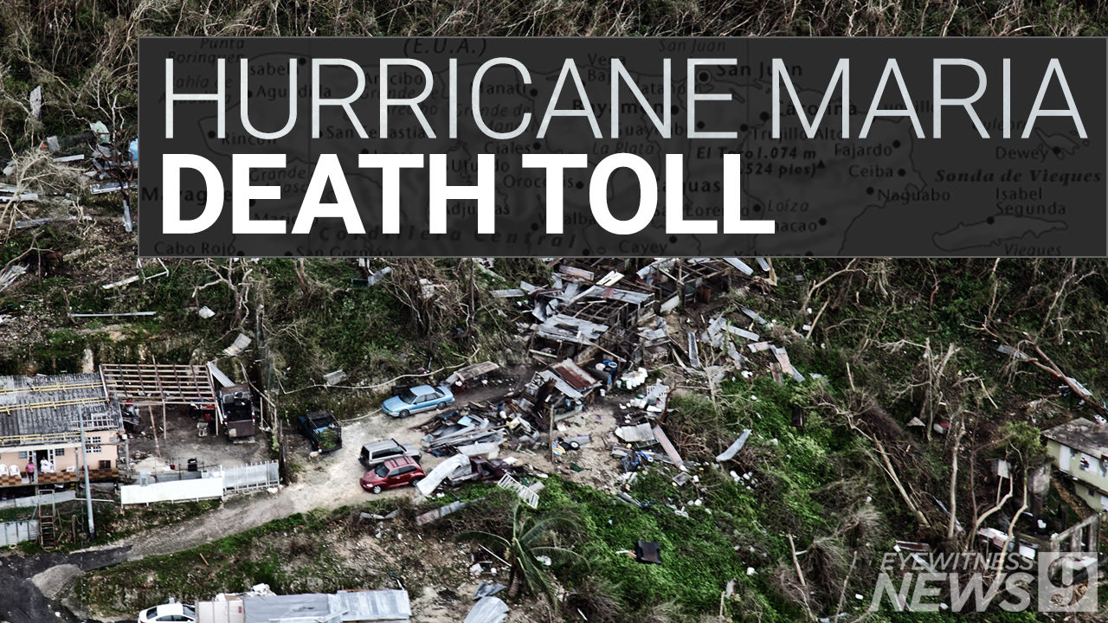

|  |
| --- |
| **death toll** |

*the number of people who die because of an event such as a war or an accident:*

The day after the explosion the death toll had risen to 90.  
Meanwhile, the death toll is expected to rise in the Philippnines as Mangkhut leaves a wake of destruction and landslides.

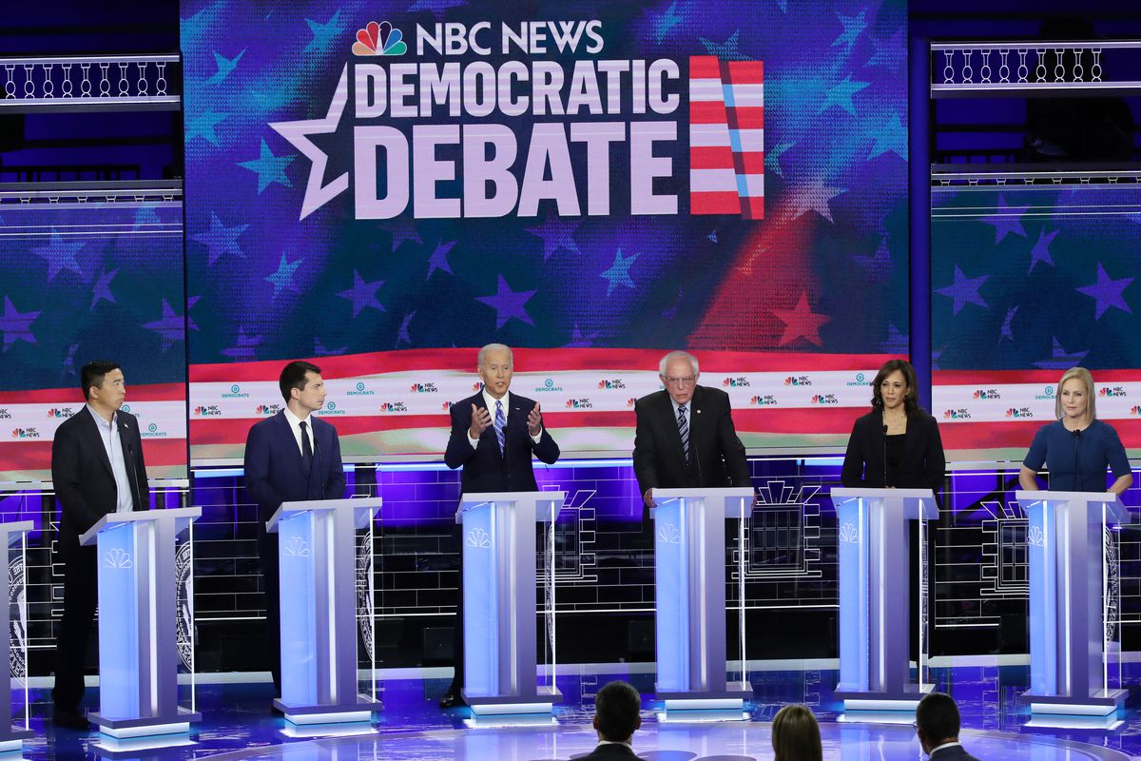

|  |
| --- |
| **debate : discuss: argue** |

*serious discussion of a subject in which many people take part:*

Education is the current focus of public debate.  
How we proceed from here is a matter for debate.  
Over the year we have had several debates about future policy.

|  |
| --- |
| **decade** |

A decade is a period of ten years.

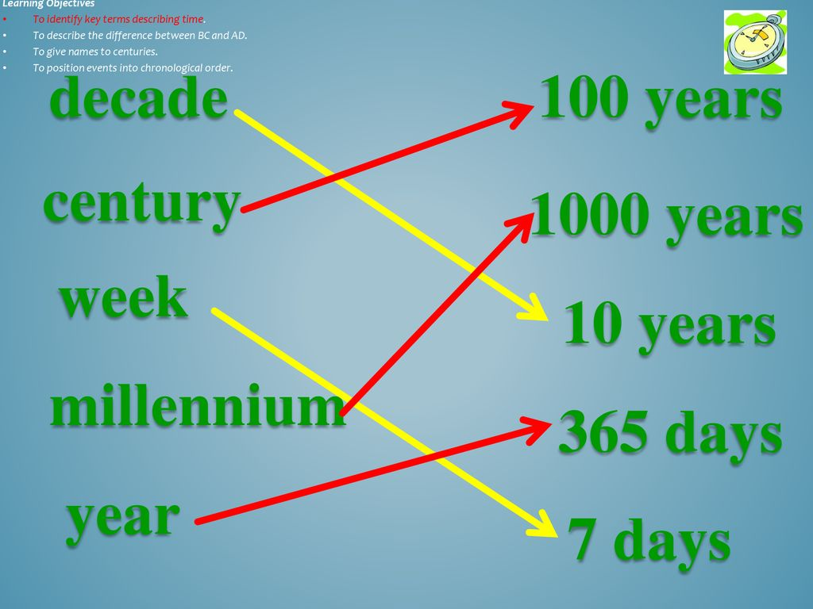

|  |
| --- |
| **decide: make a decision** |

They have to decide by next Friday.  
In the end, we decided to go to the theatre.  
She decided (that) she would travel to India.  
I can't decide what to do.



|  |
| --- |
| **decision** |

She has had to make some very difficult decisions.  
The company will reach/come to/make a decision shortly.



|  |
| --- |
| **deep** |

The hole is so deep you can't see the bottom.  
The water's not deep here - look, I can touch the bottom.  
The sky was deep blue.

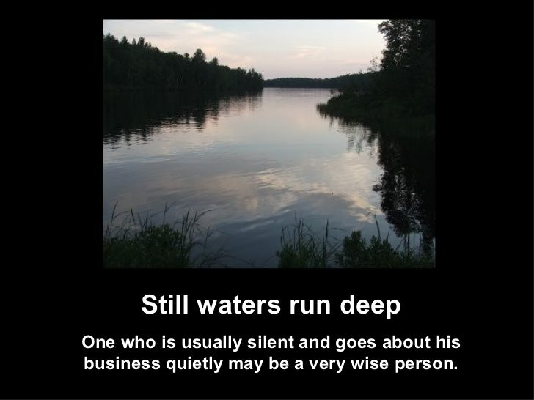

|  |
| --- |
| **deer : buck** |

When I saw her, I was like a deer in headlights.

[caption id="attachment_7519" align="alignnone" width="600"]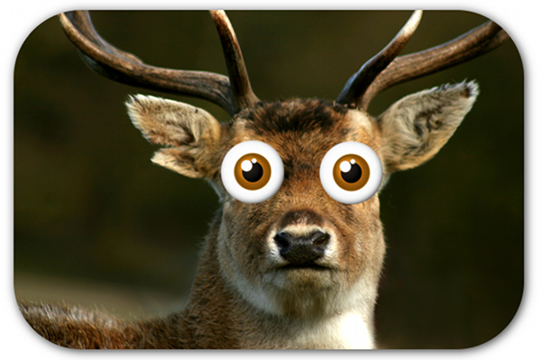 deer in the headlights[/caption]

|  |
| --- |
| **defeat** |

An Imperial French army under the command of Emperor Napoleon was defeated by combined armies.

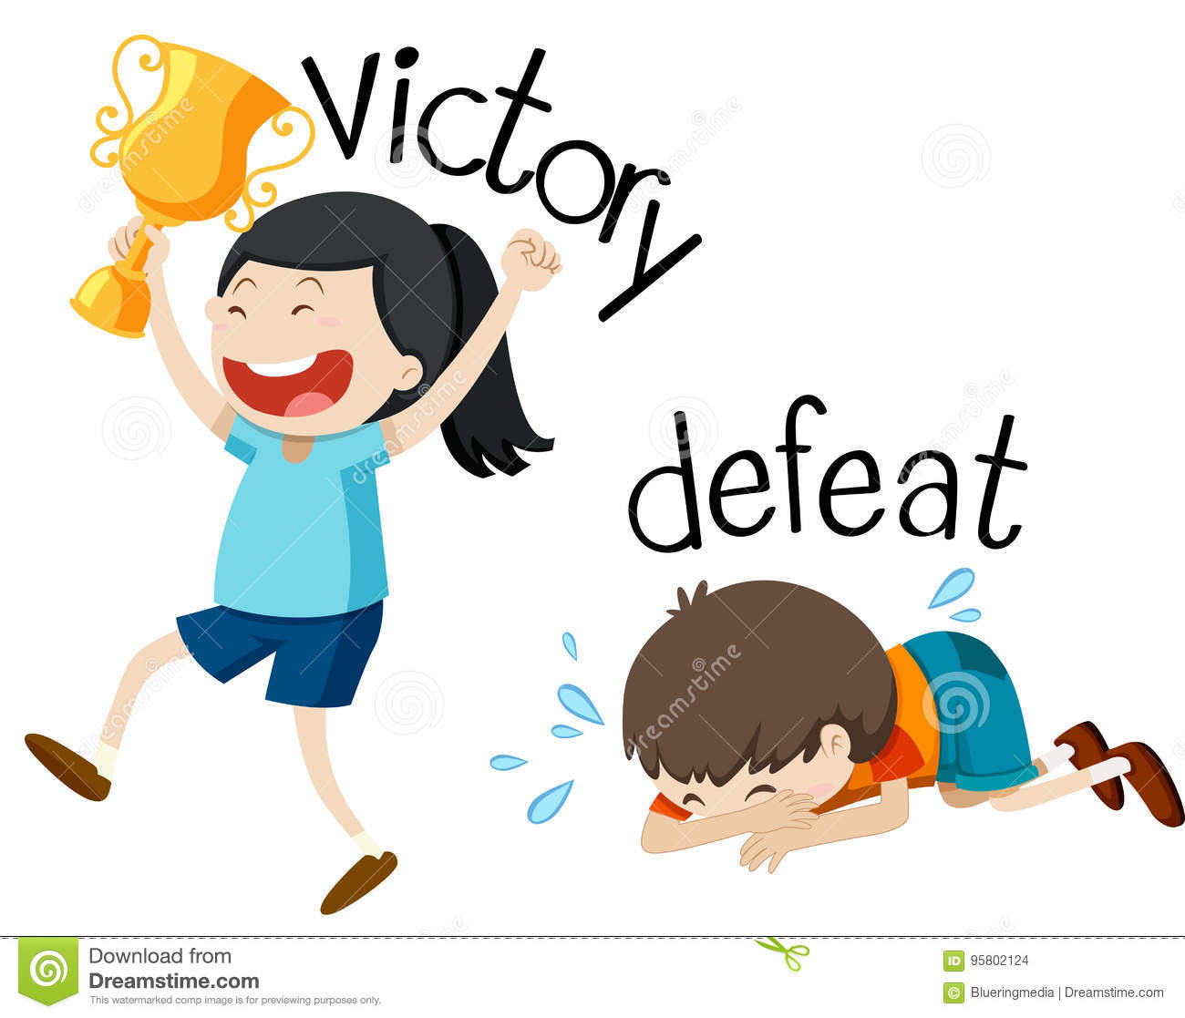

|  |
| --- |
| **defence** |

Whenever anyone criticizes her husband, she immediately jumps to his defence.  
The team has a strong attack, but its defence is weak.

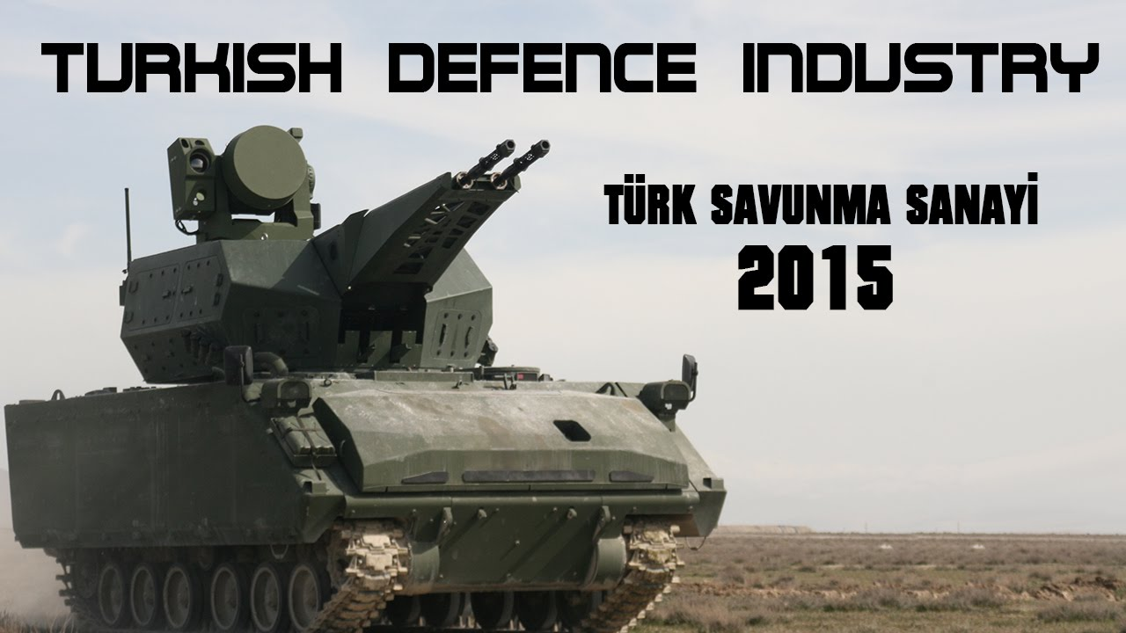

|  |
| --- |
| **defend** |

They are fighting to defend their beliefs / interests / rights.  
He vigorously defended his point of view.

|  |
| --- |
| **define :  explain** |

Before I answer your question, could you define your terms a little more?  
It is very difficult to define the concept of beauty.

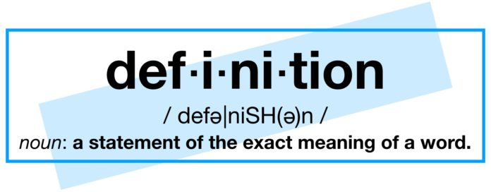

|  |
| --- |
| **definition : explanation** |

The legal definition of what is and what is not pornography is very unsatisfactory.  
What is the definition of "health"?

|  |
| --- |
| **definitely** |

Have you definitely decided to go to America?  
Are you going to have children? Oh, definitely.

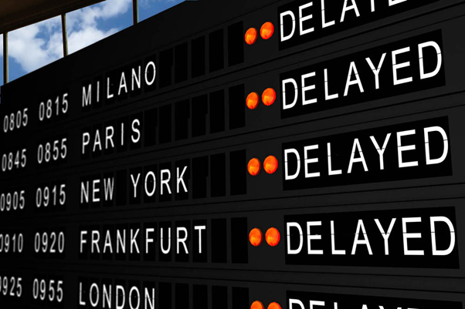

|  |
| --- |
| **delay /diley/** |

The manager (who was) responsible for the delay was fired.  
Could we delay the meeting a few days?  
I think we should delay deciding about this until next year.  
Turkey should lift the state of emergency without delay.  
My plane was delayed by an hour.

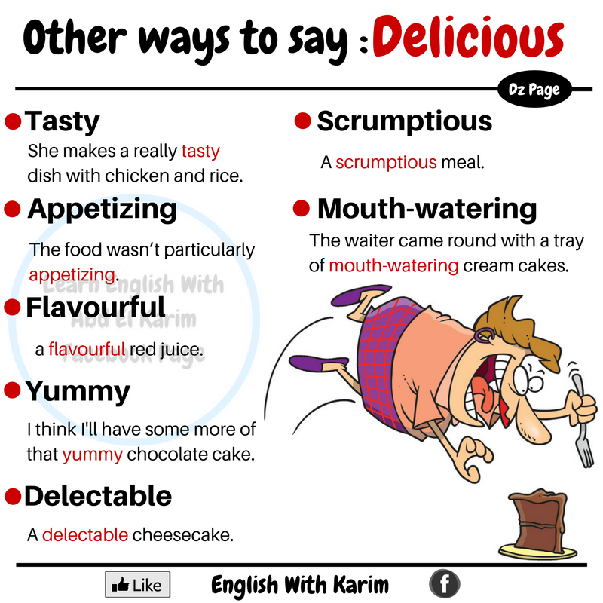

|  |
| --- |
| **delicious : tasty** |

The delicious smell of freshly made coffee came from the kitchen.  
That was a delicious dinner, thank you.

|  |
| --- |
| **dentist** |

You should have your teeth checked by a dentist at least twice a year.  
When did you last visit the dentist?  
The dentist kept me waiting for ages.

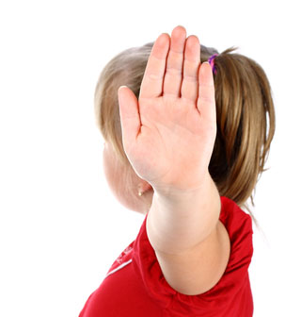

|  |
| --- |
| **deny ≠ confess** |

He denied that he had killed her.  
He denied the allegations.

|  |
| --- |
| **departure *≠ arrival*** |

Our departure was delayed because of bad weather.  
Do you know the departure time of your flight?



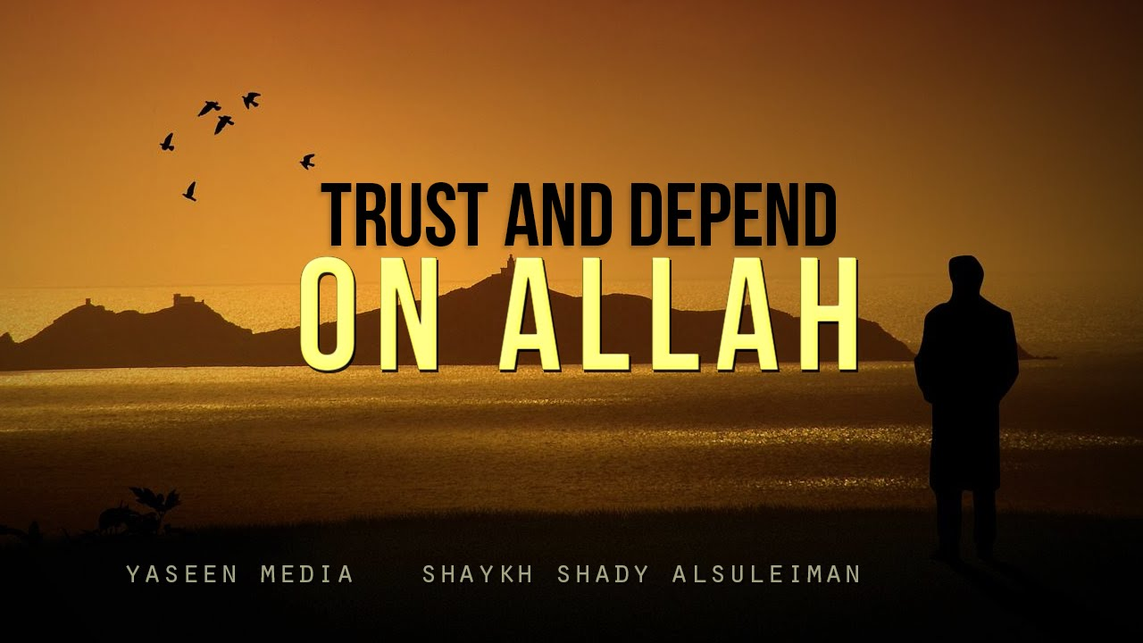

|  |
| --- |
| **depend on / upon** |

You can always depend on Jane in a crisis – she always keeps her promises.  
The length of time spent exercising depends on the sport you are training for.  
Your choice of exercise must also depend on your general state of health.

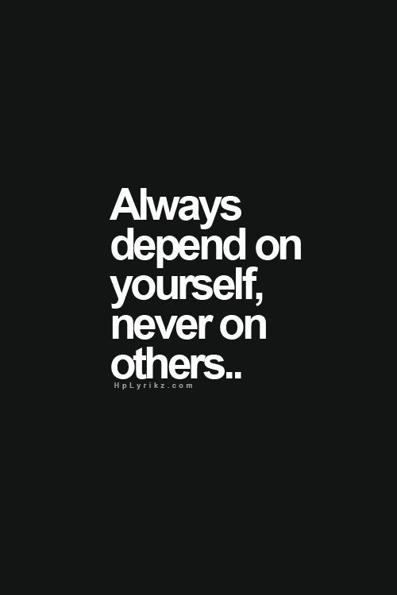

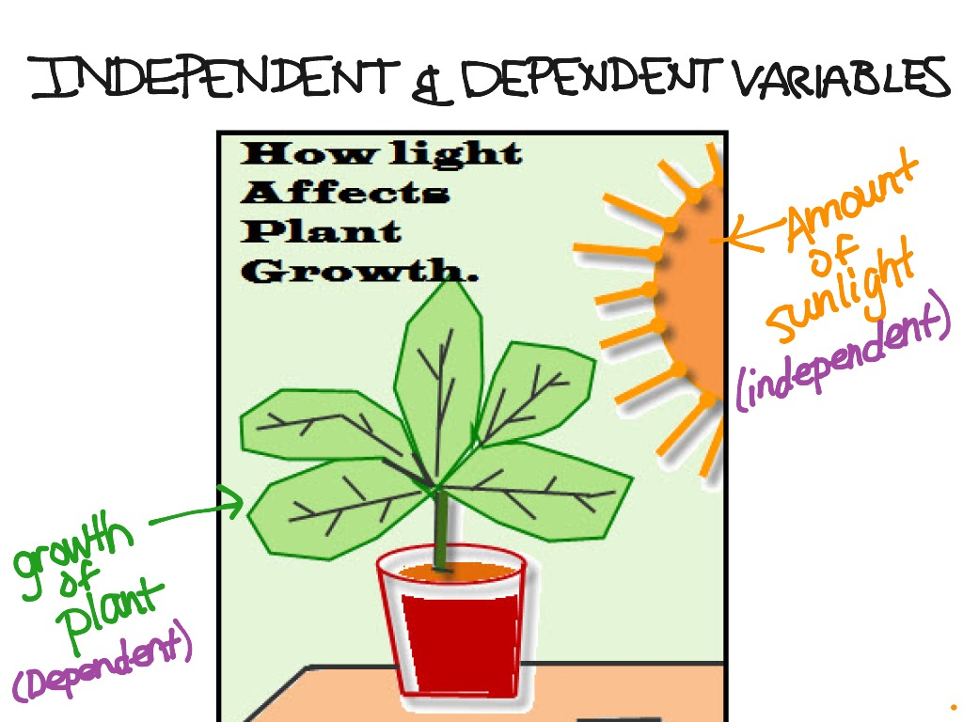

|  |
| --- |
| **dependent** ≠ **independent** |

Most children remain dependent on their parents while at university.  
He is dependent on his father for support.  
He's still financially dependent on his parents.  
Norway’s economy is heavily dependent on natural resources.  
Do you have any dependent children (=who you are still supporting financially)?

|  |
| --- |
| **depressed** |

He seemed a bit depressed about his work situation.  
She became deeply depressed when her husband died.



|  |
| --- |
| **depressing** |

I find this weather so depressing.  
It's depressing to think that we've got five more years of this government!

|  |
| --- |
| **describe : explain** |

Let me describe to you how it happened.  
Please describe to the court exactly what you saw.

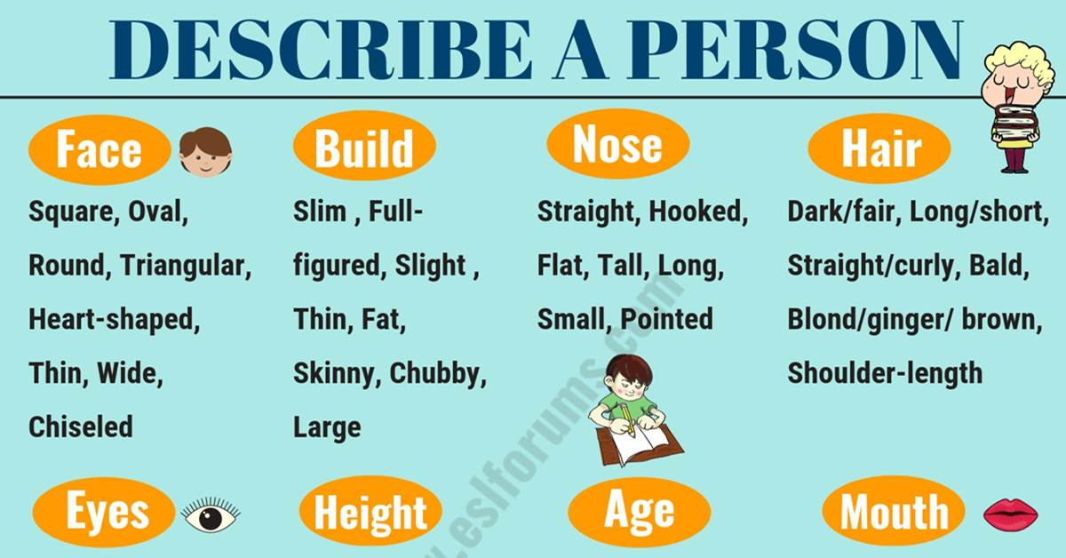

|  |
| --- |
| **desert** |

They were lost in the desert **/dezırt/** for nine days.  
When you live in the desert, water is your most vital resource.

He deserted his wife and family for another woman.

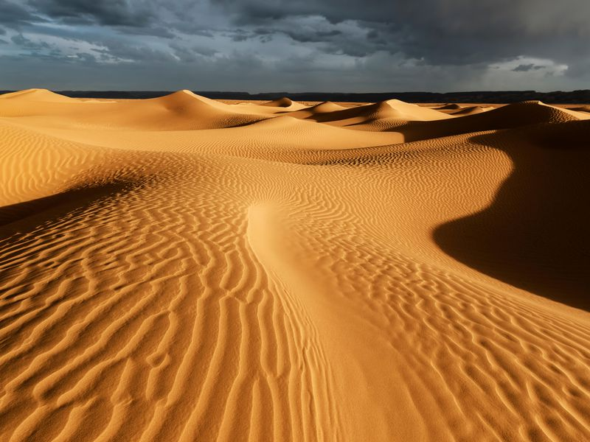

|  |
| --- |
| **deserve** |

After all that hard work, you deserve a holiday.  
Chris deserves our special thanks for all his efforts.

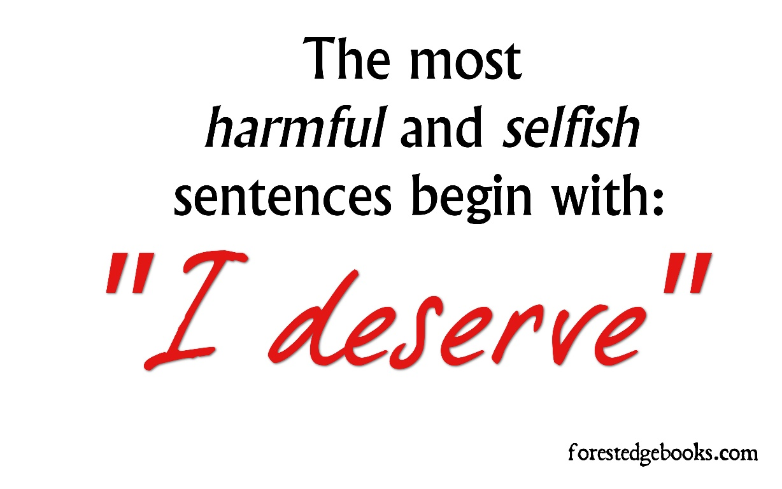

|  |
| --- |
| **dessert** |

What are we having for dessert?  
If you make the main course, I'll make a dessert. **/disört/**

|  |
| --- |
| **despite : in spite of** |

I still enjoyed the week despite the weather.  
Despite repeated assurances that the product is safe, many people have stopped buying it.  
He managed to eat a big lunch despite having eaten an enormous breakfast.

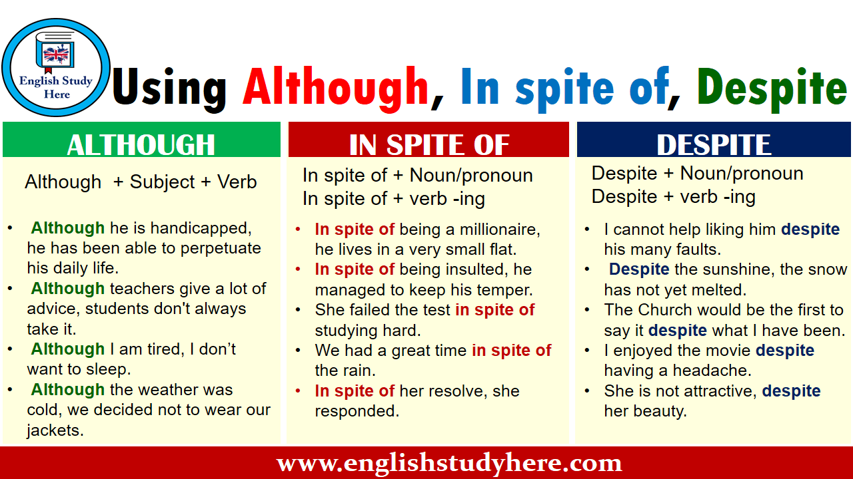

|  |
| --- |
| **destiny :  fate** |

The destiny of our nation depends on this vote!  
People want to control/determine their own destinies.

|  |
| --- |
| **develop** |

This exercise is designed to develop the shoulder and back muscles.  
It's fascinating to watch how a baby changes and develops over time .  
We have to develop a new policy/strategy to deal with the problem.  
The company is spending $650 million on developing new products/technology.  
our essay is good, but you need to develop your ideas more fully (= give more details).



|  |
| --- |
| **development** |

A good diet and lots of exercise are essential for a child’s healthy growth and development.  
I’m in charge of product development (= the creation and design of new products) for the company.  
There have been significant computer developments during the last decade.

|  |
| --- |
| **The Devil** |

The Devil, in Christianity, Islam, and Judaism, is the most powerful evil spirit.  
The villagers believed a devil had taken control of his body.

Praying 5 times a day keeps The Devil / Hell away!

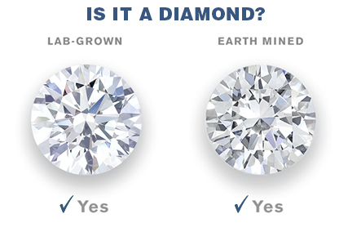

|  |
| --- |
| **diamond** |

He had worked in the diamond mines of South Africa.  
Shall I wear the diamonds or the pearls with this dress?

|  |
| --- |
| **diarrhea** |

The loss of fluids through diarrhea can cause dehydration.  
We collected data on diarrhoea for all children in the villages aged between 3 months and 5 years.

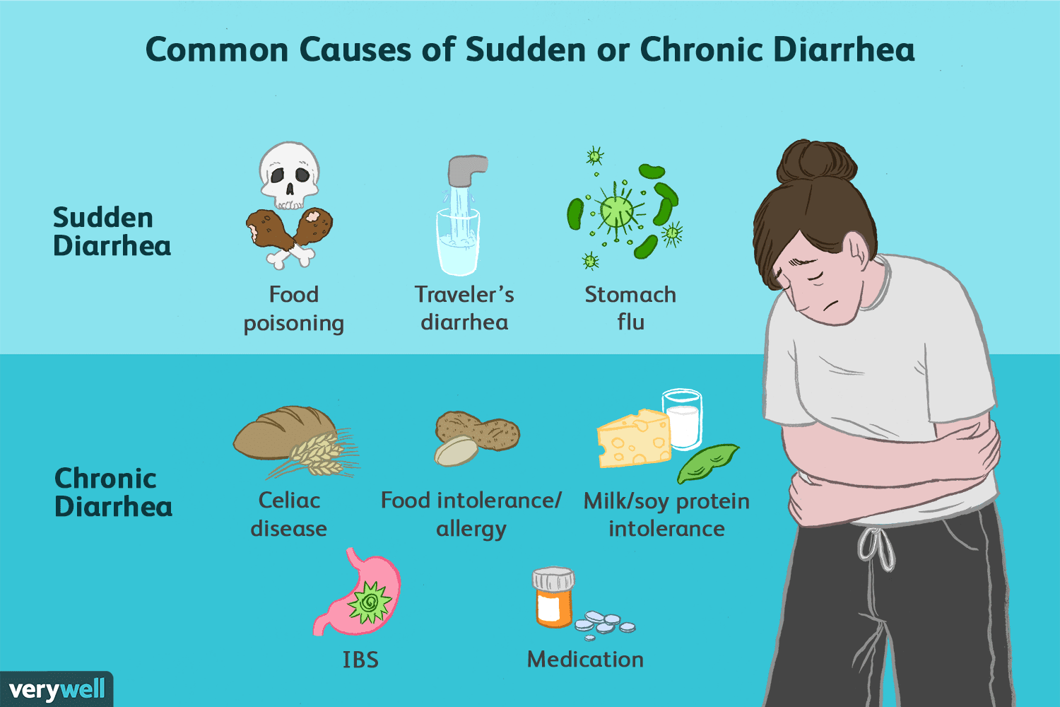

|  |
| --- |
| **dictionary** |

Our online dictionary is regularly updated with new entries.  
We advise all our students to use a good dictionary.  
If you don’t understand the meaning of a word, look it up in a dictionary.  
I often check the dictionary for spelling and pronunciation.

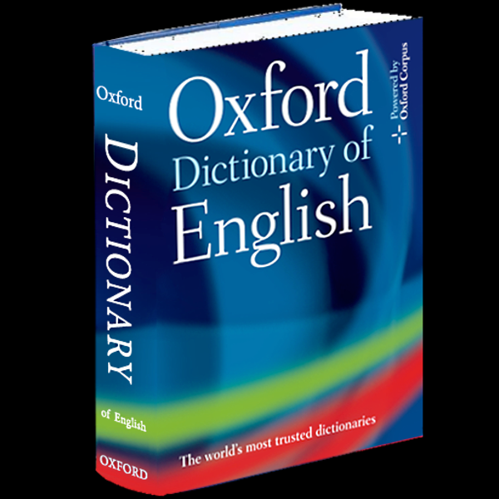

|  |
| --- |
| **difference** |

It doesn’t make any difference to me.  
It doesn’t make any difference to me.  
What's the difference between an ape and a monkey?  
Is there any significant difference in quality between these two items?

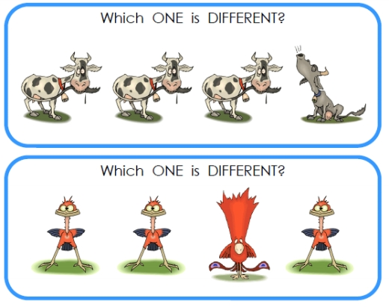

|  |
| --- |
| **different** |

She seems to wear something different every day.  
He's different now that he's been to college.  
We're reading a different book this week.  
Emily is very/completely/entirely different from her sister.  
Emily and her sister are completely different.  
There are many different types/kinds of bacteria.

|  |
| --- |
| **dirty** |

His clothes were untidy and he had dirty hands.  
We were hot and dirty after working in the garden all afternoon.



|  |
| --- |
| **disappear : vanish** |

I'll just say the magic word and the rabbit will disappear - Abracadabra!  
The search was called off for the sailors who disappeared in the storm.  
I can't find my keys anywhere - they've completely disappeared.  
The sun disappeared behind a cloud.  
We looked for her but she had disappeared into the crowd.

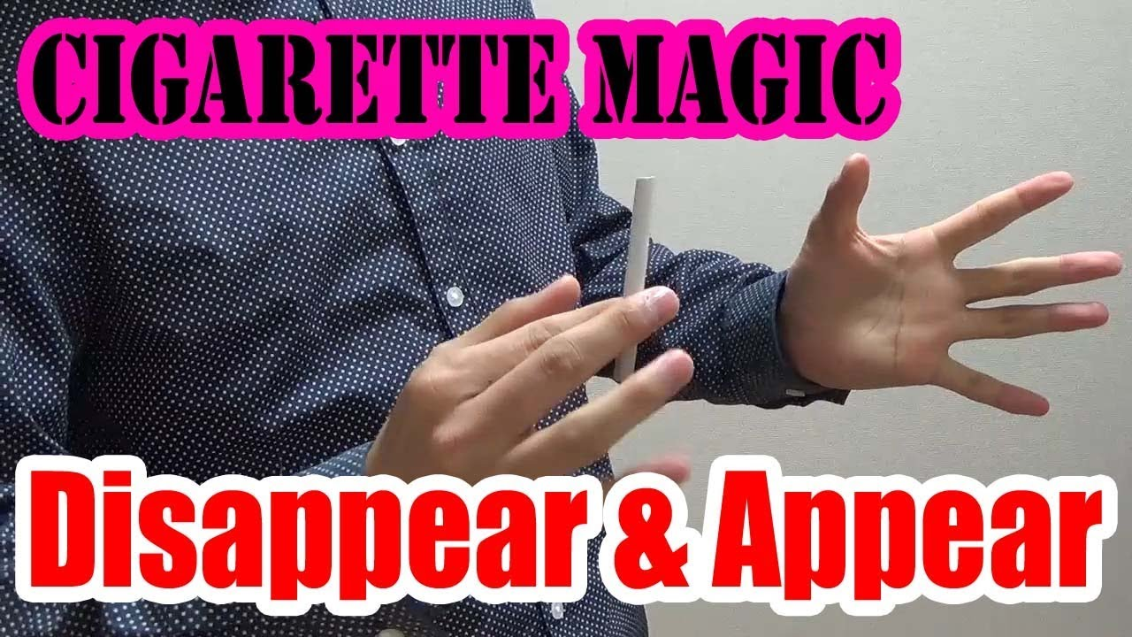

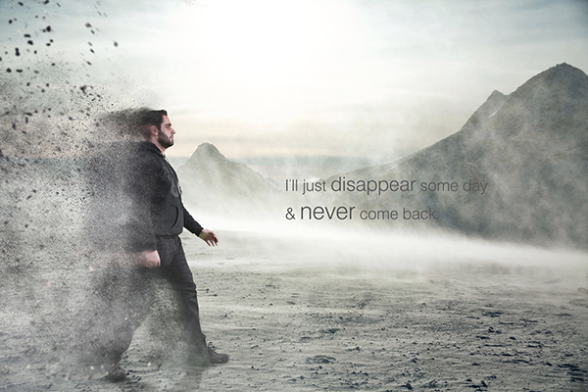

|  |
| --- |
| **disappointed: frustrated** |

If you're expecting Dad to let you borrow his car, you're going to be sorely disappointed.  
We were deeply disappointed at/about the result.

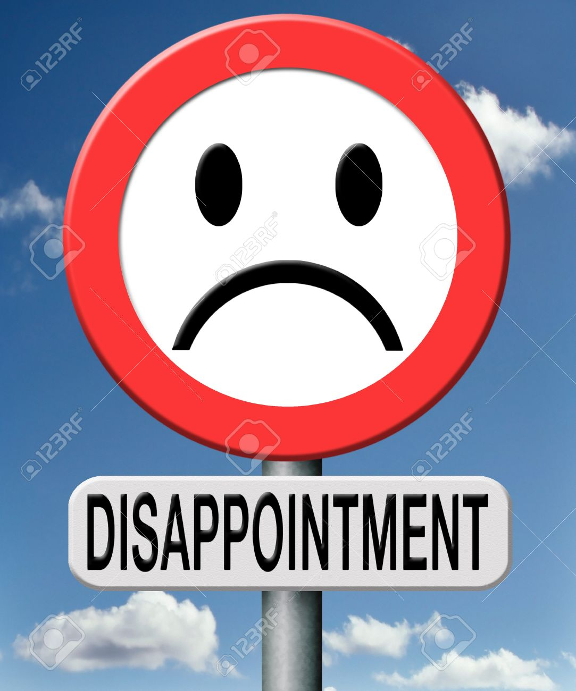

|  |
| --- |
| **disappointing** |

The response to our advertisement has been somewhat disappointing.  
What a disappointing result!

|  |
| --- |
| **discuss : debate : argue** |

I'm very interested in your idea - shall we discuss it over lunch?  
Stop shouting and let's discuss this reasonably.  
We have been discussing the possibility of working together.



**Tartışmak: Discuss, Argue, Debate**

**discuss:** Birşey üzerinde karara varmak için konuşmak, tartışmak

We should discuss on this holiday opportunity. (Bu tatil fırsatı üzerine konuşmamız/tartışmamız gerekir. ( Bir karara varmak için ))

**argue:** Hemfikir olmadığınız durumda sinirli bir şekilde tartışmak.

I wish my brother wouldn't argue with me all the time. (Keşke kardeşim her zaman benimle tartışmasa. ( Anlaşmazlık nedeniyle))

**debate:** Herhangi bir konu üzerinde resmi bir şekilde tartışmak

Politicians are discussing yesterday's demonstration. (Politikacılar dünkü mitingi tartışıyorlar.)

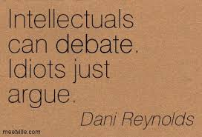

|  |
| --- |
| **discussion** |

We will hold/have discussions with employee representatives about possible redundancies.  
The matter is still under discussion (= being considered).

|  |
| --- |
| **dish**: tabak;yemek;bulaşık |

*food prepared in a particular way as part of a meal:*  
Paella is a Valencian rice dish considered as Spain's national dish.  
Can you recommend any vegetarian dishes?

What kinds of meat dishes do you serve?  
Ne çeşit et yemeklerini servis yapıyorsunuz?

The cook prepares different dishes every day.  
Aşçı her gün farklı yemekler hazırlar.

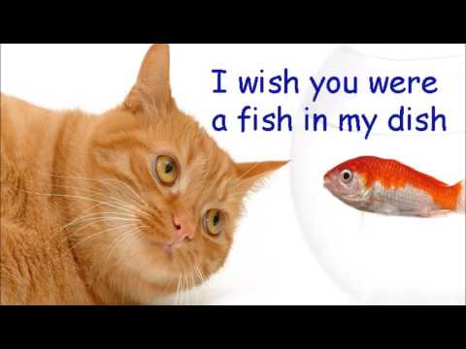

**I wish you were a fish in my dish.**

*The dishes are all the plates, glasses, knives, forks, etc., that have been used during a meal:*  
Who’s going to do/wash the dishes (= clean the plates, glasses, etc.)?

*A dish is a type of parabolic antenna designed to receive microwaves from communications satellites.*  
**satellite dish: dish**

|  |
| --- |
| **dishwasher** |

This dishwasher even washes pots and pans .

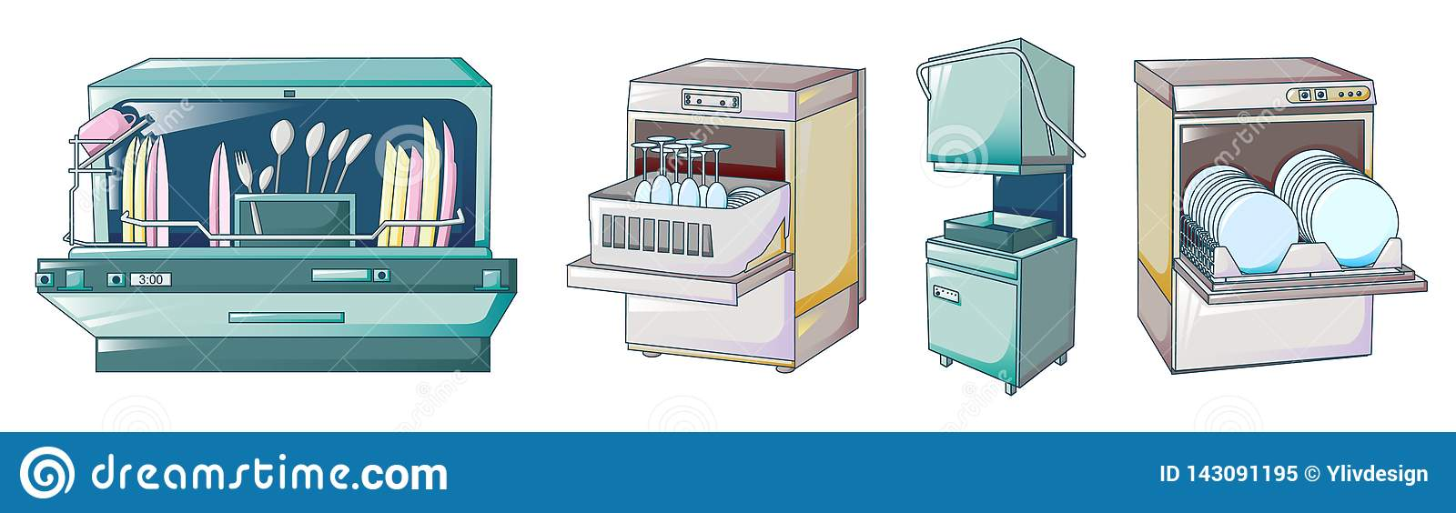

|  |
| --- |
| **disaster** |

It would be a disaster for me if I lost my job.  
They took no measures to avoid the disaster.

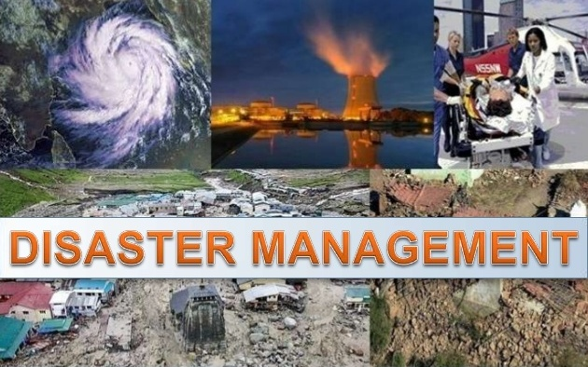

|  |
| --- |
| **distance** |

The average distance from the Earth to the Moon is 384,403 kilometres, thirty times the diameter of the Earth.

Don't try distancing yourself from me by calling me Mr Calder.

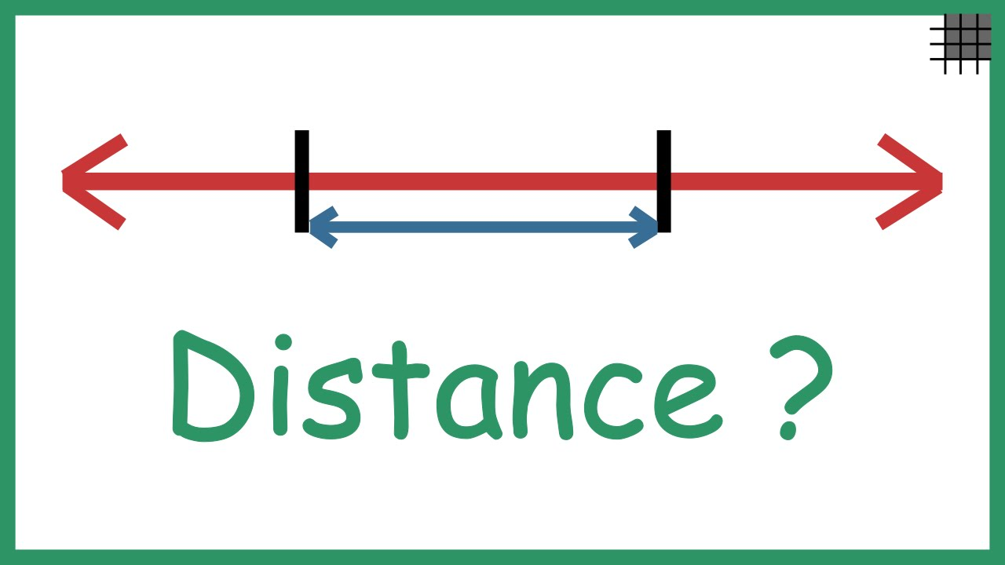

|  |
| --- |
| **distinguish** |

He's colour-blind and can't distinguish the difference between red and green easily.  
I sometimes have difficulty distinguishing Spanish from Portuguese.

[caption id="attachment_7321" align="alignnone" width="538"]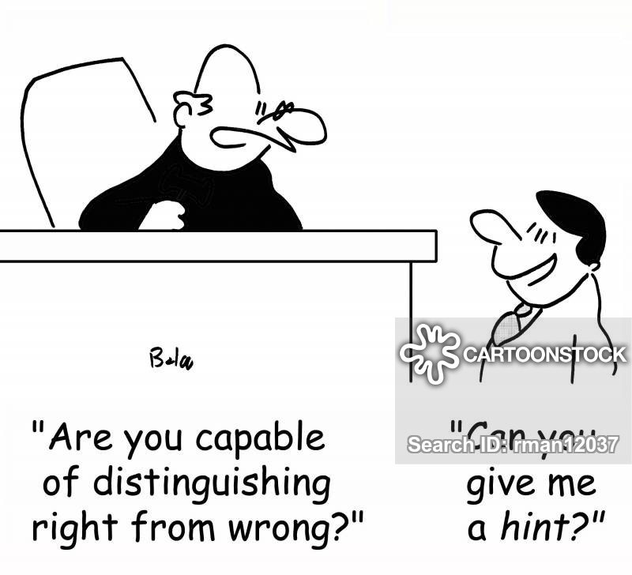 'Are you capable of distinguishing right from wrong?'[/caption]

|  |
| --- |
| **disturb** |

Sorry to disturb you, but I have an urgent message.  
What disturbs you most about this latest development?  
Please don't disturb your sister - she's trying to do her homework.  
I'm sorry to disturb you so late, but my car's broken down and I don't have my phone with me.

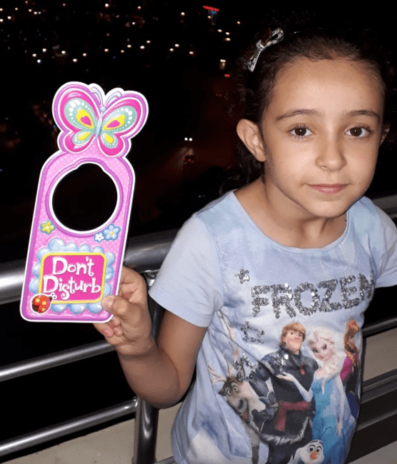

|  |
| --- |
| **divorce *≠ marry*** |

They stayed friends after their divorce.  
One in three marriages ends in divorce.

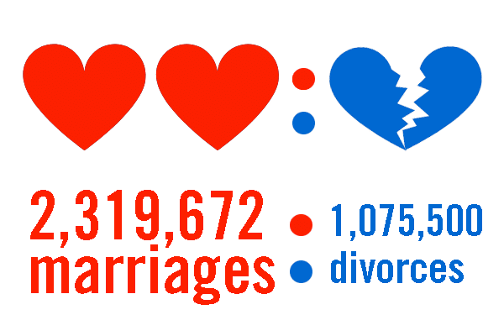

|  |
| --- |
| **do** |

What are you doing over the weekend?  
The only thing we can do now is wait and see what happens.  
What do you do (for a living)? (= What is your job?)  
What can I do for you? (= How can I help you?)

|  |
| --- |
| **dolphin** |

After studying dolphins, people built submarines to move quickly in the ocean and stay under the water for a long time.  
Dolphins move quickly in the water not only to be safe from danger.  
Dolphins use their tails to go faster and their fins to change direction.  
Whales and dolphins look like fish, but they’re really mammals!  
While many other animals, such as chimpanzees and dolphins, live in groups and communicate, scientists don’t know for certain whether they can talk and share complicated ideas.

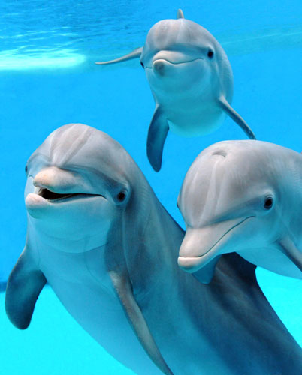

|  |
| --- |
| **donkey** |

Emily had a donkey ride at the fair.  
The little donkey struggled under its heavy burden.

[caption id="attachment_8372" align="alignnone" width="550"]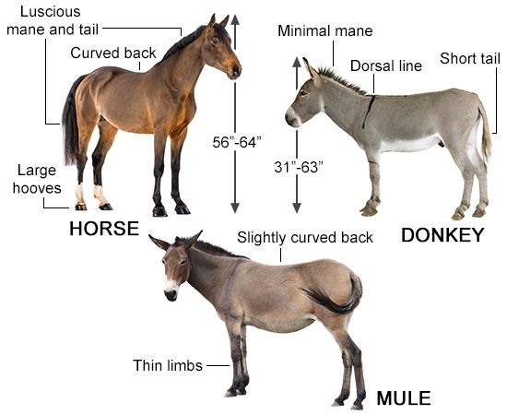 at - eşek - katır[/caption]

|  |
| --- |
| **doubt** |

I have no doubt that he can do it.  
No doubt about it.

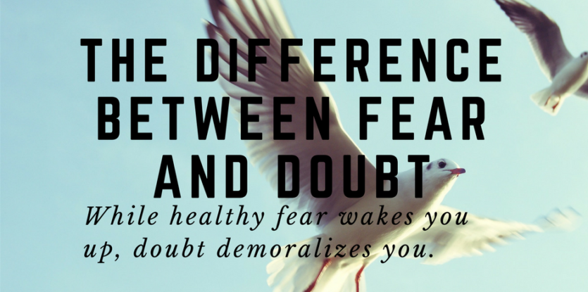

|  |
| --- |
| **do favour : to help** |

Could you do me a favour - would you feed my cat this weekend?

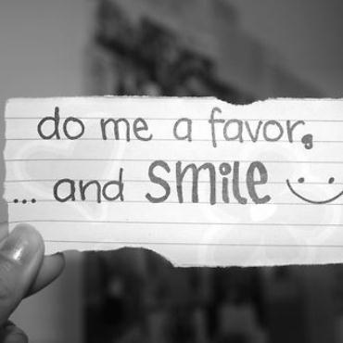

|  |
| --- |
| **downtown  ≠ suburb** |

I work downtown, but I live in the suburbs.  
She lives in a really beautiful apartment downtown.  
Stacy works downtown.

|  |
| --- |
| **draw** |

Jonathan can draw very well.  
The children drew pictures of their families.  
Draw a line at the bottom of the page.  
I'll draw you a quick map if you're worried about finding the hotel.



**to attract attention or interest:**

He's an excellent speaker who always draws a crowd.  
Could I draw your attention to item number three on the agenda?



|  |
| --- |
| **dream** |

I'd always dreamt of owning my own house, but I never thought it would come true one day.  
I had lots of dreams last night.  
I had a dream about you last night.  
Sometimes I have a strange dream in which I try to speak but I can’t.  
I’d always wanted to go to Africa and at last my dream came true.



|  |
| --- |
| **dress** |

Sheila wore a long red dress.  
Have you chosen your wedding dress yet?  
She was wearing exactly the same dress as I was.  
She was wearing a black and white spotted dress.  
My husband dresses the boys while I make breakfast.

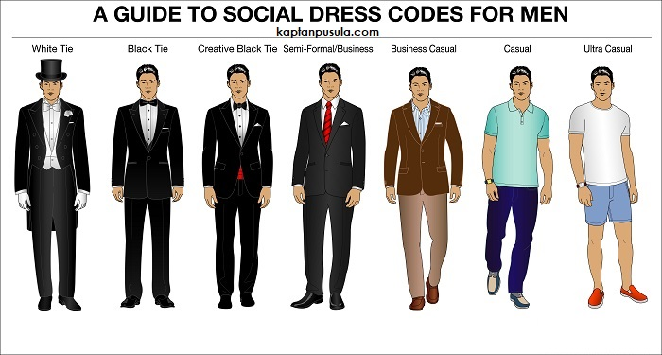

|  |
| --- |
| **dress code** |

Most evenings there's a party and the dress code is strict - black tie only.

|  |
| --- |
| **drink** |

I think apple juice is your favourite drink, isn't it?  
Would you like a drink of water/tea/juice?  
He drank three glasses of water.

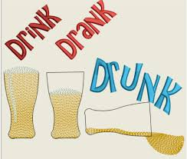

|  |
| --- |
| **drive** |

I asked him to drive more slowly, but he didn't take any notice.  
The police fined her for driving through a red light.  
She drives the kids to school every morning.

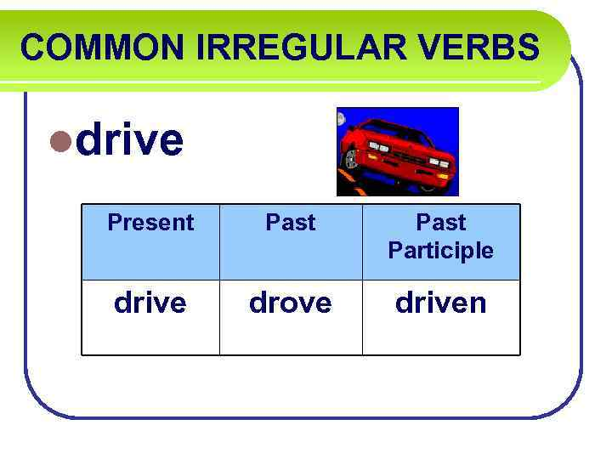

|  |
| --- |
| **driver** |

The driver lost control of his car when the brakes failed, and it went at full speed down the hill.  
My mum's an excellent driver.

|  |
| --- |
| **drunk** |

When she's drunk she's capable of saying awful, rude things.



|  |
| --- |
| **duck** |

Some poultry farmers keep turkeys and ducks as well as chickens.

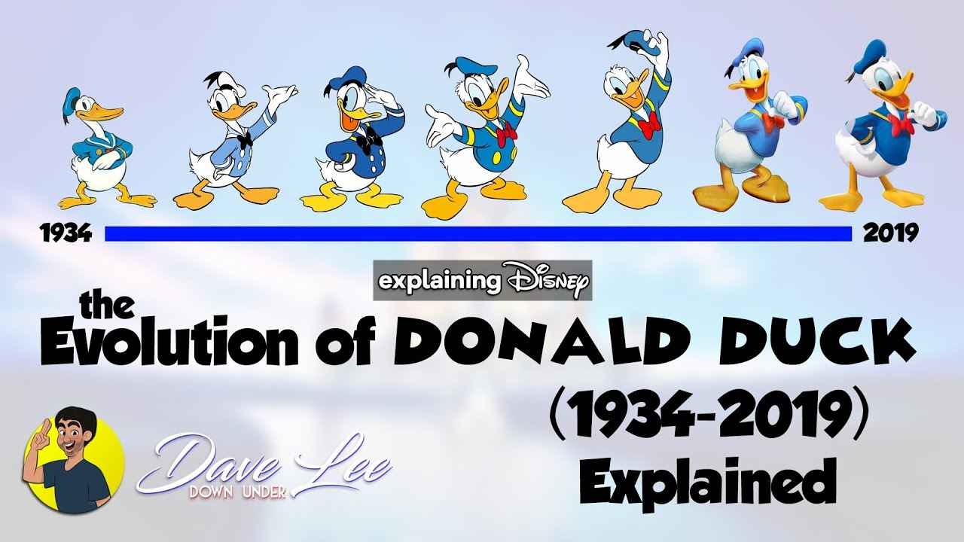

|  |
| --- |
| **due to : owing to** |

The meeting is now due to take place next week.  
Britain is due to leave the European Union on March 29.

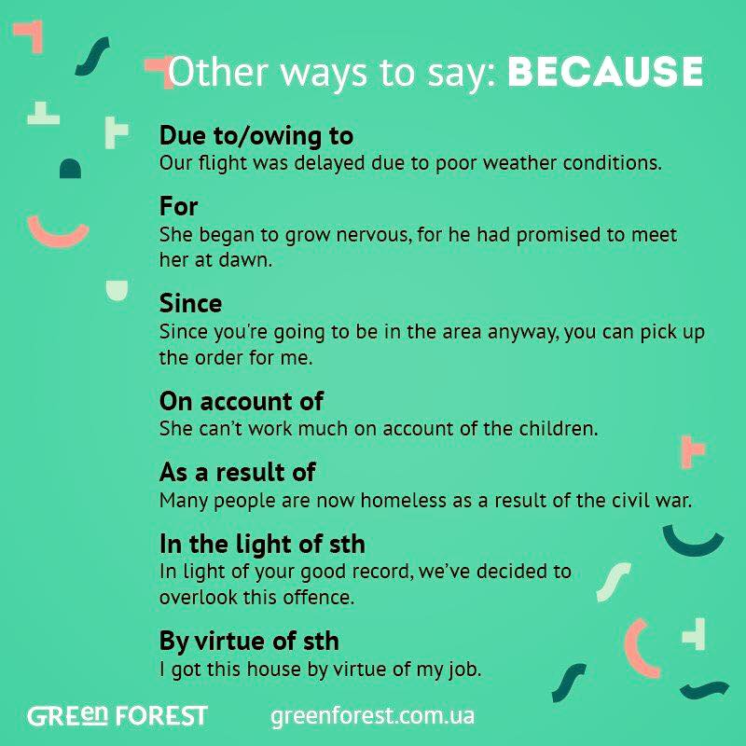

*because of:*

A lot of her unhappiness is due to boredom.  
The bus was delayed due to heavy snow.

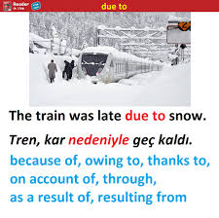

|  |
| --- |
| **during** |

During the summer she worked as a lifeguard.  
He slept calmly during the early part of the night.  
Did you hear the storm during the night?  
During the summer we spend a lot more time out of doors.

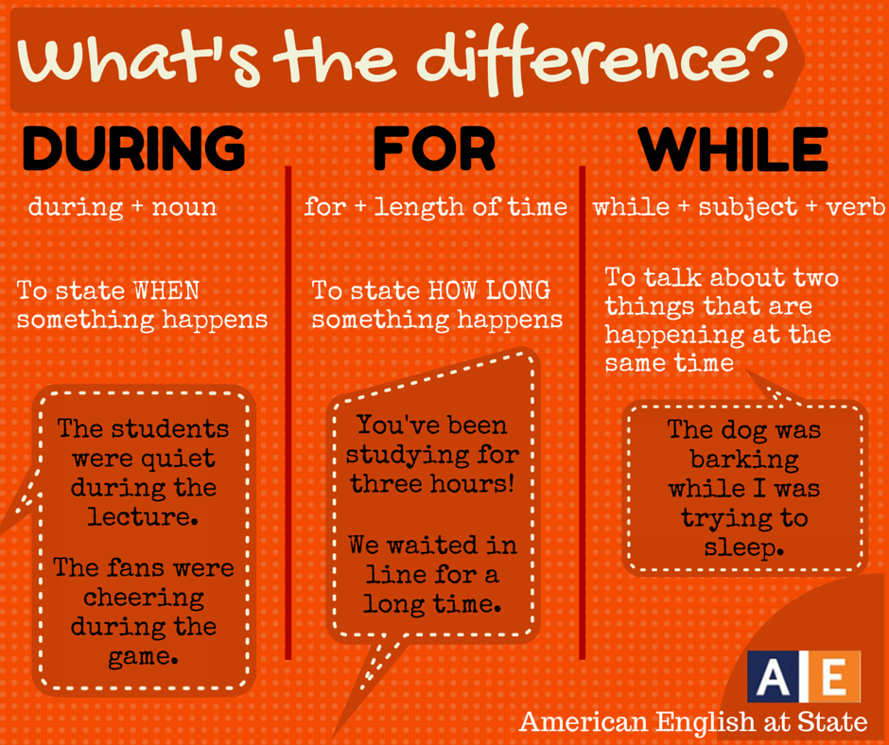

|  |
| --- |
| **duty** |

It's our duty to preserve the planet for future generations.  
I felt it was my duty to tell them the truth.



|  |
| --- |
| **E** |

|  |
| --- |
| **eager : keen to** |

Sam was eager to get home and play with his new toy.  
I was eager to get back to work as soon as possible.  
He’s a bright kid and eager to learn.  
A crowd of eager young students were already waiting outside.

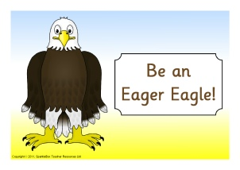

|  |
| --- |
| **eager beaver** |

***a person who is willing to work very hard***

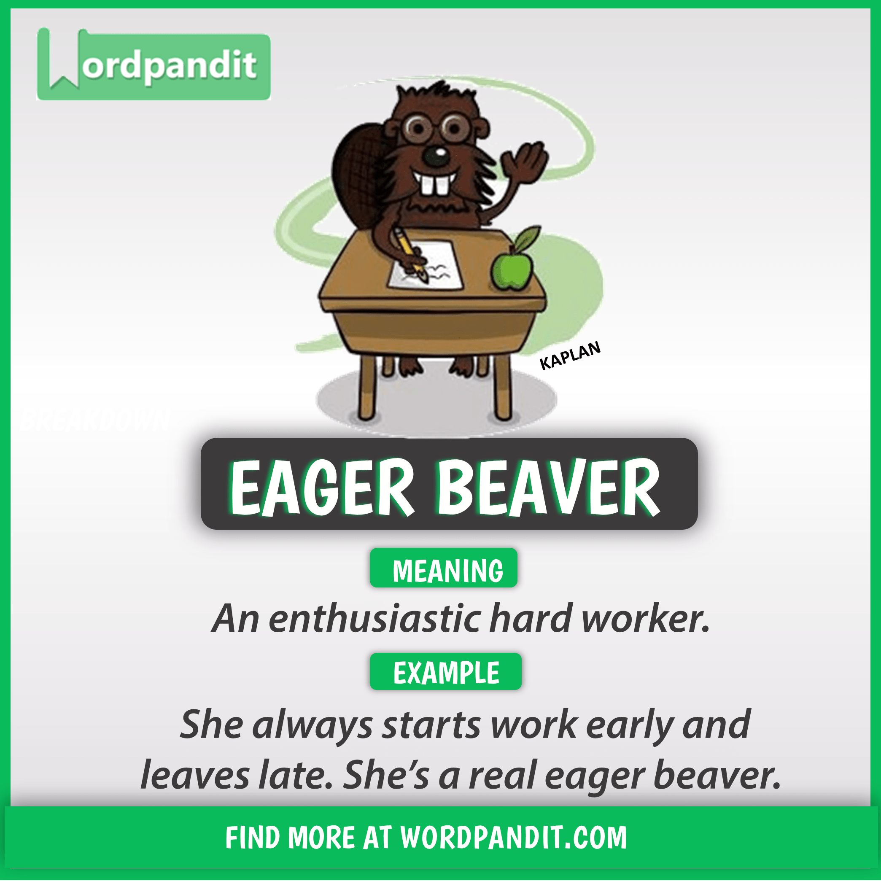

|  |
| --- |
| **eagle** |

Eagles are one of the largest and strongest birds in the world.

|  |
| --- |
| **early** |

If you finish early you can go home.  
If you arrived earlier, you'd have more time.  
I like being a little early for interviews.

[caption id="attachment_7719" align="alignnone" width="348"]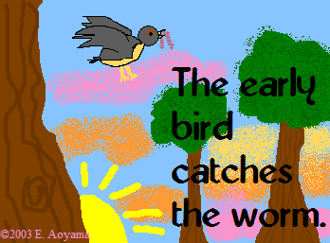 The early bird catches/gets the worm.[/caption]

|  |
| --- |
| **earn : gain** |

How much do you earn, if you don't mind me asking?  
You can't expect to earn a living from your painting.

|  |
| --- |
| **earth : world** |